**Branching: A Powerful Version Control Tool**

In Git, branching allows you to create independent lines of development for your project. Imagine it like creating copies of your project at specific points in time, where you can experiment with changes without affecting the main codebase. This is incredibly useful for various scenarios:

* **Feature Development:** Work on a new feature without interfering with the stable version.
* **Bug Fixes:** Isolate a bug fix on a separate branch for testing before merging it back into the main code.
* **Experiments:** Try out different ideas or code variations without affecting the main project.

**Commands for Branching**

Here's a breakdown of the commands you provided, along with a clear explanation:

1. **Create a New Branch:**
   * git branch hello-world-image: This command creates a new branch named " hello-world-image " that diverges from the current branch (usually main). It essentially creates a pointer to a specific commit in your Git history.
   * git checkout hello-world-image: This command switches your working directory to the newly created "feature-branch." Now, any changes you make will be isolated to this branch.

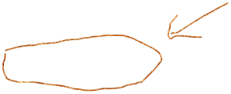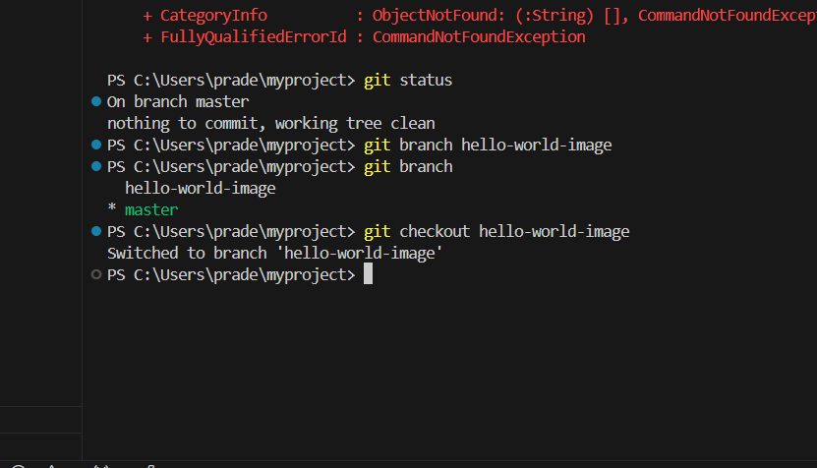

**Combined Command:**

* + git checkout -b hello-world-image: This combines both steps into one line, creating the branch and switching to it simultaneously. It's a convenient shortcut.

1. **Make Changes:**
   * Now that you're on the " hello-world-image," feel free to edit your project files. These changes won't affect the main branch until you explicitly merge them.
2. **Commit Changes:**
   * When you're happy with your work on the feature branch, use:
     + git add <files>: Stage specific files (or all modified files with git add .) to prepare them for the next step.
     + git commit -m "Implemented feature XYZ": Create a snapshot of your staged changes with a descriptive commit message (like "Implemented feature XYZ"). This message helps track your development history.

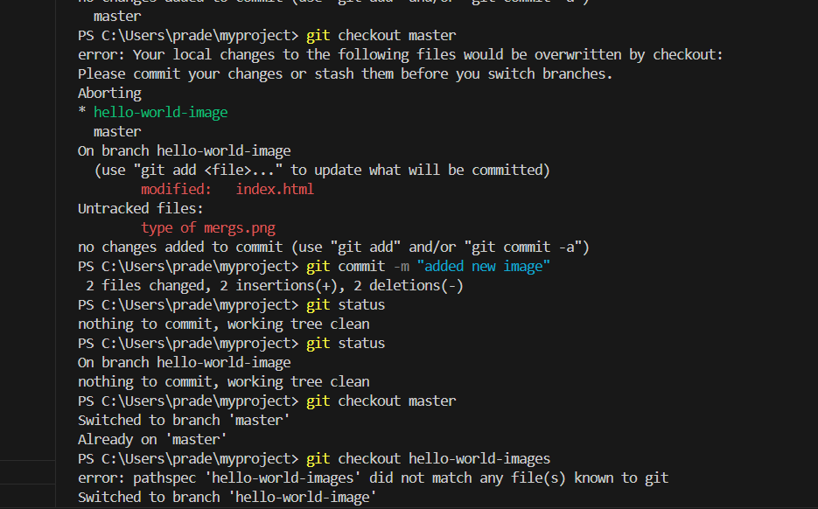

1. **Switch Branches:**
   * To return to the main branch (or any other existing branch):
     + git checkout main: This command switches your working directory back to the main branch. Any uncommitted changes on the feature branch will be preserved, but you won't be able to work on them until you switch back.

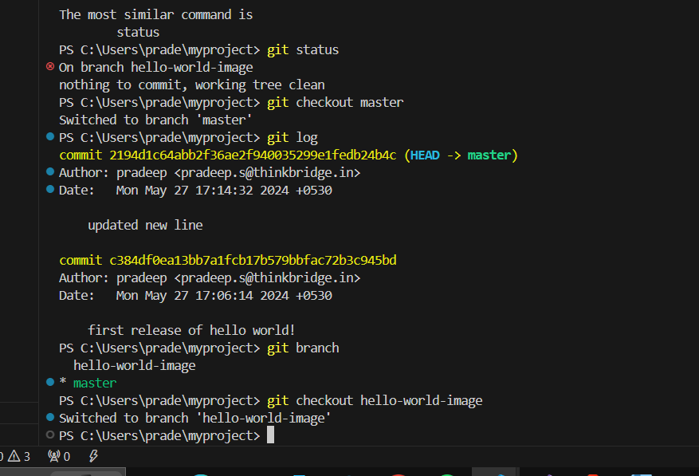

1. **Merge Branches:**
   * Once you're confident that your changes in the feature branch are ready to be incorporated into the main codebase, use:
     + git merge feature-branch: This command attempts to combine the commits from the "feature-branch" into the main branch. If there are no conflicts (changes to the same lines of code in both branches), the merge happens seamlessly.
     + **Conflict Resolution:** If there are conflicts, Git will highlight them in your files. You'll need to manually edit the files to resolve these conflicts and then commit the resolved version.

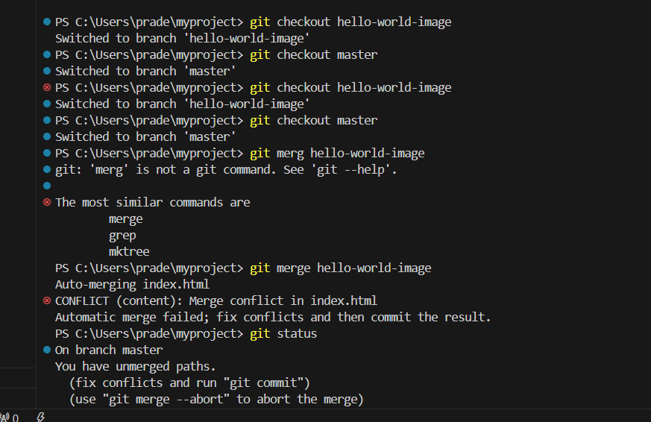

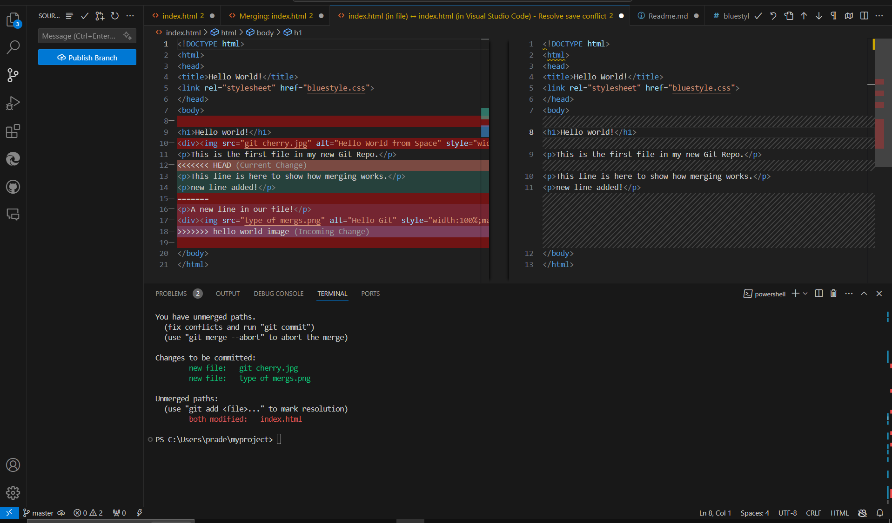

**Remember:**

* Merging integrates the changes from one branch into another. It's a permanent action, so make sure your feature branch is ready before merging.
* Using branches effectively keeps your project organized, facilitates collaboration, and allows for safe experimentation.